ENVIRONMENTAL MONITORING USING RASPBERRY-Pi

INTRODUCTION:

To read temperature and humidity data from a DHT11 or DHT22 sensor using raspberry.pi.Here is a python program using the Adafruit DHT library to accomplish this.

**STEPS:**

1. First, you'll need to install the Adafruit DHT library if you haven't already. Open a terminal on your Raspberry Pi and run the following command:

bash  
CIRCUIT :

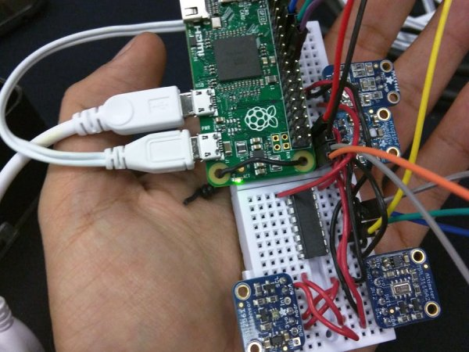

Preparing the Raspberry Pi

Installing the OS

**1.- Download the latest Raspbian.**

[https://www.raspberrypi.org/downloads/raspbian](https://www.raspberrypi.org/downloads/raspbian/)

**2.- Follow the instructions to install the Raspbian in your micro SD card.**

if you are using Linux you can follow these steps to install Raspbian Lite on your micro SD card:

– Check the device name for your micro SD by running :

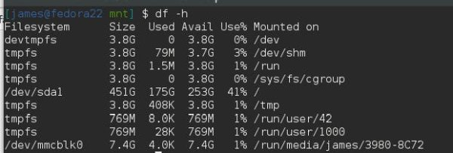

– Unmount your device with the following command

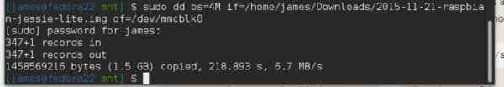

**1.- Expand the Filesystem and Enable I2C**

* Login as user: pi password: raspberry
* Execute the command sudo raspi-config in the terminal
* Select Expand Filesystem and press Enter
* Select OK and you will return to the main menu
* Select Advanced Options
* Select I2C and press Enter
* Select Yes and press Enter
* Select OK and press Enter
* Select Yes and press Enter
* Select OK and you will return to the main menu
* Select Finish and press Enter
* Select Yes and press Enter to reboot the Raspberry pi

**2.Create a Python script (e.g., temperature_humidity.py) and add the following code:**

import Adafruit_DHT

import time

# Set the GPIO pin where your sensor is connected

DHT_SENSOR = Adafruit_DHT.DHT22

DHT_PIN = 4 # Replace with the actual GPIO pin number

try:

while True:

humidity, temperature = Adafruit_DHT.read(DHT_SENSOR, DHT_PIN)

if humidity is not None and temperature is not None:

printf("Temperature: {temperature:.2f}°C, Humidity: {humidity:.2f}%")

else:

printf("Failed to retrieve data from the sensor. Check the wiring.")

time.sleep(2) # You can adjust the sleep duration as needed

except KeyboardInterrupt:

printf("Program terminated by user.")

except Exception as e:

printf(f"Error: {str(e)}")

**3.Save the script and run it:**

python tempThe script will continuously read the temperature and humidity values from the DHT sensor and print them to the terminal. Press **Ctrl+C** to stop the program.

Remember that the DHT11 and DHT22 sensors may have different pinouts and require different parameters, so make sure to adjust the code accordingly. Additionally, double-check your wiring and make sure you have the necessary permissions to access GPIO pins (usually, you need to run the script with superuser privileges or add your user to the group)

**You should see the following output**

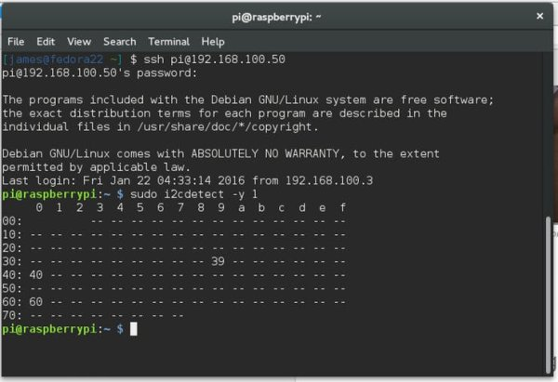

Once you finish the wiring and sensor placement your device should look something like this.

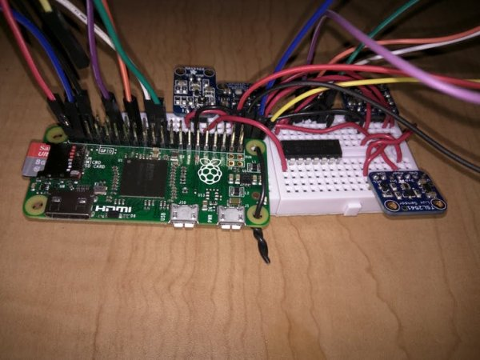

Once you finish the wiring and sensor placement your device should look something like this.

